BrightstarDB SDShare Server 1.0

The BrightstarDB SDShare Server is designed to be used to expose RDF data from existing data sources. The data produced can be easily consumed into a BrightstarDB instance or any SPARQL compliant data store. The server has a pluggable architecture to allow any data source to be exposed in accordance with the latest SDShare specification (SDShare), it comes with configurable components for ODBC enabled databases.

The SDShare Server provides two main features; firstly it exposes existing data sources as feeds of data that comply with the SDShare specification. Second, it runs a client service that can consume and process valid SDShare feeds. Both the producer and consumer services offer a pluggable framework to support different data sources and data destinations. In addition, a data source adaptor is provided for exposing data via any ODBC compliant database and a client component is also provided that can send updates from an SDShare feed to any SPARQL 1.1 compliant endpoint and BrightstarDB instance.

The following diagram shows the server architecture.

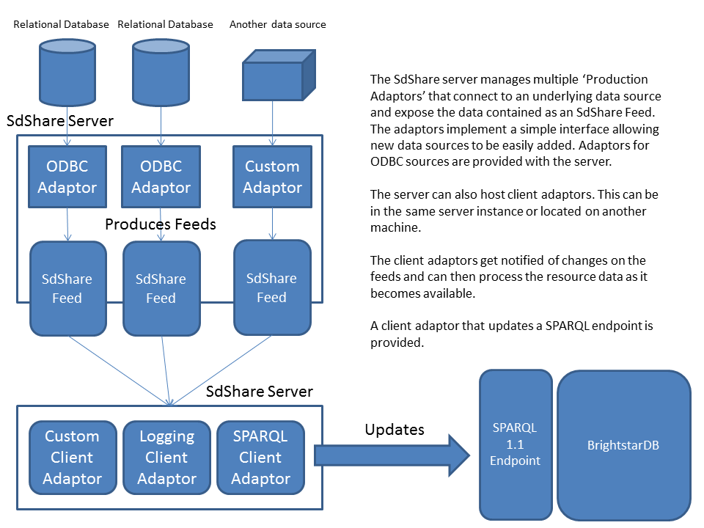

# Installation

The SDShare Server is provided as .zip file. The following steps should be followed to start the SDShare Server.

1. Ensure .NET 4.0 or greater is installed.

2. Unpack the contents of the .ZIP file into a folder on the machine where it will run. (It is suggested

that it be added into the "C:\Program Files (x86)\BrightstarDB\SDShare" folder). This location will be called the [INSTALLDIR].

3. OPTIONALLY: To aggregate data into BrightstarDB ensure a BrightstarDB database instance is

running.

4. OPTIONALLY: To allow updates from exposed data sources to be aggregated into a BrightstarDB

instance ensure the SPARQL endpoint is correctly configured.

5. Before attempting to run the service ensure that you have obtained and installed a valid license. Trial licenses are available from the BrightstarDB website.

## Installing and Running the SDShare Server as a Windows Service

1. Open a Windows Command Prompt with an account that has Administrator rights and go to the

'[INSTALLDIR]\Service' directory.

2. Type: 'C:\Windows\Microsoft.NET\Framework64\v4.0.30319\installutil -i BrightstarDB.SdShare.

Server.exe' followed by pressing 'Enter'. Note that the path to the .NET framework may be different.

3. Start the service from the Control Panel. It appears in the Services list as 'SdShare Server'.

## Running the SDShare Server from the Command Line

The server does not need to be installed as a Windows Service. It can be run from the command line.

To run the service from the command line:

1. Open a Windows Command Prompt with an account that has Administrator rights and go to the

'[INSTALLDIR]\Service' directory.

2. Type: 'BrightstarDB.SdShare.Server.exe' and press ‘Enter’.

# Service Configuration

The BrightstarDB.SdShare.Server.exe.config file contains the configuration settings for the service. There are two settings of note:

<appSettings>

<!-- The location of the main sdshare configuration file -->

<add key="SdShare.ConfigurationLocation" value="C:\Program Files (x86)

\BrightstarDB\SdShareServer\Service\SdShareConfig.xml"/>

<!-- The port that the service should run on -->

<add key="SdShare.ServerPort" value="9090"/>

</appSettings>

If changes are made to this file the service must be restarted for the changes to take effect.

# Accessing the Service

To check that the service is running open a web browser and navigate to the following URL (note that if the port has been changed in the configuration the link will need to be modified to match this value);

http://localhost:9090/sdshare/collections

The following sections provide an overview of how to configure the SDShare Server.

# Exposing ODBC Data Sources

Before starting ensure that the appropriate ODBC drivers and connections are installed, set up and tested. This can be done via the Windows ODBC Administration console.

The server uses a configuration file to set up and expose different data sources. This file is located in the [INSTALLDIR]\Service folder and is called SdShareConfig.xml. The file provided is an annotated example of how to exposes an ODBC data source.

It describes feeds exposed from a table with a change log and also from a table that has no valid change log.

# Consuming SDShare Data Sources into BrightstarDB

The SDShare Server can also consume valid SDShare feeds. The configuration identifies feeds and registers adaptors to receive data from these feeds. One of the adaptors provided will send updates to a SPARQL 1.1 endpoint provided by BrightstarDB.

The [INSTALLDIR]\Service folder contains a example file called SdShareConfig.xml. This file contains an annotated example of how to set up the server to consume feeds and use the SPARQL update adaptor.

# Developing Custom SDShare Data Providers

The SDShare Server allows custom providers to easily be included. The following steps should be follows to create a custom provider:

1. Create a new DLL project in Visual Studio. Include a reference to BrightstarDB.SdShare.dll.
2. Create a new public class with a parameterless constructor that inherits from CollectionProviderBase, or directly implements ICollectionProvider.
3. Implement the required methods and properties to fetch data from the custom source.
4. In the SdShare config name the type and assembly as shown for the default OdbcCollectionProvider.

# Developing Custom SDShare Client Adaptors

A similar approach can be take for developing client adaptors. A client adaptor receives data from registered feeds.

To implement a custom adaptor create a new DLL project and a class that implements the ISdShareClientAdaptor interface.

The adaptor is registered as shown in the sample for consuming data sources.